Sethatevy Bong

Project 2

Pseudocode for the program:

1. prompt and ask user to input the country

2. display menu and ask user to choose the converter of temperature, distance, and weight or quit

3. user input the value

4. display dialogue with converted measurement of choice to Imperial system

5. display farewell and student information

Output screenshot

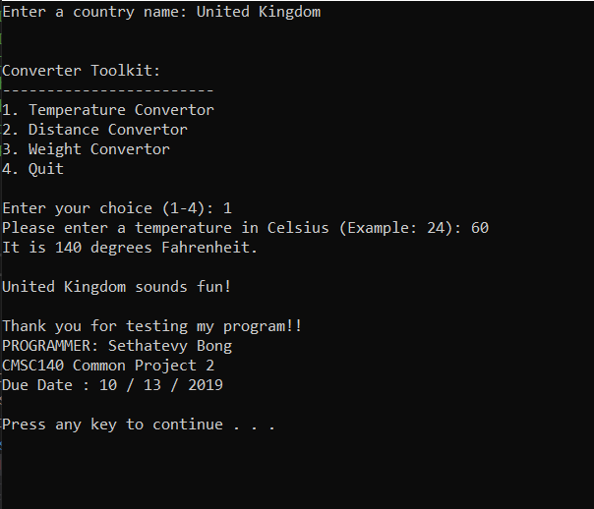

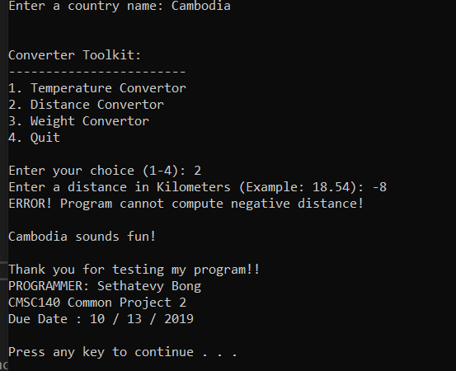

Lesson Learned

I feel more comfortable with this project than the first project. I tried to use the if/ else statements, but it couldn’t figure out how to put a condition in an if statement inside an if else statement. Then, I realized that switch statement is easier to use. I more familiar with the how to write program to get a display of digits after the decimal through the use of setprecision(), if statement, switch statement, and relational and logical operators to check numeric ranges (this is where it took me so much time to correct my program, but this also allows me to remember what I did wrong).

In sum, I enjoy doing this project, it really helps me becoming more familiarize with chapter 4. I also notice that I still need further revision for chapter 4. After I received help from the Ackerman Learning Center, now I know the mistake that I made. I think going to the computer programming lab is really helpful. In the future, I plan to spend more time over there and do my programming studies.

Test Plan

|  |  |  |
| --- | --- | --- |
| Data Item | Test Case #1 Values | Test Cast #2 Values |
| Country | United Kingdom | Cambodia |
| Conversion | Choice 1 (Temperature Converter) | Choice 2 (Distance Converter) |
| Input value | 60 | -8 |
| Expected Output | 140 | Error Message |
| Did the test pass? | Yes | Yes |
| Actual Output | 140 | Error Message |